**Who We Are**

NIEMOpen is a community-driven standards development initiative producing multiple specifications that are voluntary consensus standards as defined in the OMB Circular A-119, and in compliance with the open-standard mandate in section 12(d) of Public Law 104-113. MilOps is one of 18NIEM sub-committees.

The MilOps subcommittee captures and catalogs DoD-specific exchanges, as defined by mission managers and supporting reference model, while providing the governance and framework necessary to develop those exchanges.

**What We Do**

Problem Statement: DoD lacks the ability to manage enterprise-level data; impacting interoperability and Globally Integrated Operations.

Purpose: The MilOps sub-committee ("MilOps") provides and maintains unique military operations and mission data components used to define NIEM Message Exchange Packages (MEPs) that satisfies mission critical information sharing requirements within DoD, and/or Federal government agencies, and Mission Partners.

MilOps works towards the alignment of data standards within DoD, aimed at improving the visibility, understandability, accessibility, trust, and interoperability of shared data. MilOps is continuing the development of information exchange tools as a reusable resource within DoD.

**20 Years of NIEM**

**The Genesis of NIEM**

Did you know NIEM (National Information Exchange Model) began taking shape in 2003 with the Global Justice Information Sharing Initiative? This early work, alongside the formation of the Department of Homeland Security, laid the foundation for a standardized approach to data exchange.

**NIEM's Global Reach**

Formally launched in April 2005 by the CIOs of DHS and the Department of Justice, NIEM has grown from a US-focused initiative to a globally recognized model. Today, **all 50 states and numerous federal agencies are utilizing or exploring NIEM**, with benefits reaching Europe, the Americas, Australia, and Asia!

**NIEM's Transition to OASIS**

What’s new? In October 2022, NIEM transitioned to OASIS, a leading standards development organization. This move opens the door for NIEM to become an official international standard, making it even more accessible to organizations worldwide.

**NIEM's Continued Evolution**

With seven releases under its belt – the latest being NIEM 6.0 – the NIEM Program continues to mature and expand its impact. Learn more about NIEM and its future at [link to NIEM website].

**Who’s Using NIEMOpen**

* US DoD and Government
  + US Air Force – Cursor on Target (CoT)
  + US Army – Tactical Infrastructure Enterprise Services (TIES)
  + US Navy – Maritime Information Sharing Environment
  + Special Operations Forces (SOF)
  + Joint Non-kinetic Effects (JNKE)
  + Tactical Service Oriented Architecture (TSOA)
  + Warfighter Mission Area Architecture Federation and Integration Portal (WMA AFIP)
  + FBI – Incident Reporting National Data Exchange System (N-DEX)
  + FBI – National Crime Information Center (NCIC)
  + MIL-STD 6016 (Link-16, TDL)
  + MIL_STD 6017 (VMF, XML)
  + MIL-STD 6040 (USMTF)
  + NORAD/NORTHCOM – Situational Awareness Geospatial Enterprise (SAGE)
  + FEMA – National Incident Management System (NIMS)
  + CDC – Emergency Preparedness & Response Exchange Requirements
* FVEY
* NATO – NATO Core Data Framework
* Global, Public, & Private Business & Industry

**MilOps in Action**

Exploratory Meetings with

* AFRICOM
* C2IE
* Logistics

**Implementation Updates**

* USMTF to NIEM – DISA

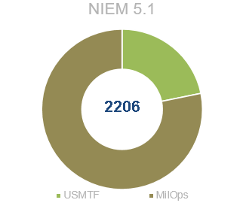 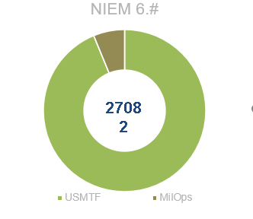

* NCDF STANG 5653 & Data Lake – NATO
* Electromagnetic Spectrum Data Semantics (EMS) – DISA
* Universal Command and Control (UC2) 2 4.0 – DISA